**De Funds**

**Description:**

A Fully Decentralized Crowdfunding Platform with voting mechanism. Users can create and fund campaigns using ETH. Smart Contracts ( Crowdfund.sol and CrowdfundFactory) manage campaign logic, ensuring transparency and security.

**Demo:**

<https://hyhen115.github.io/DeFunds/>

the demo contract is deployed on Sepolia Ethereum Testnet, and please connect to MetaMask Wallet on Sepolia Ethereum Testnet to proceed or use the functions of the dapp- DeFunds.

**Background:**

**Current Crowdfunding Platform:**

1. **High platform Fees**
2. **No Refunds to the donators if campaign fails**
3. **Campaign owners have no Flexibility for Deadlines, leading to failed campaigns and waste of Donations**

**How De Funds solve it:**

1. **No Platform Fees**

Users only need to pay for Gas Fees.

1. **Allow Refunds**

Users can Request Refunds if Campaign Fails.

1. **Allow Campaign Owner Propose Deadline Extensions**

Campaign Owner can Propose a 3-day Deadline Extension Proposal to their Donators. [details on page below]

**App Functionalities:**

**Connect to Wallet & Explore Different Campaigns**

To Use Any functions of the Dapp, **You** **MUST connect your MetaMask Wallet** and make sure **your wallet’s network is same as the Dapp contract deployed on**.

In the Demo provided uses [Ethereum Sepolia Testnet](https://sepolia.dev/).

To Connect to Your Wallet, you can press the “**Connect Wallet**” Button on the Top Right Corner of the navigation bar:



After Successful Connection You will able to see Your address Icon on the Top Right Corner:

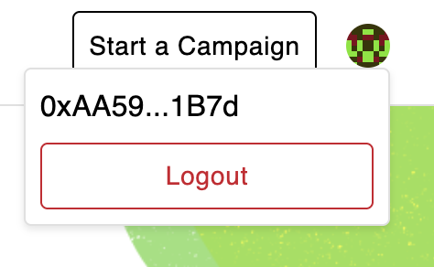

To Logout of the Dapp, just click the icon, and press the “Logout” button. (this Logout button Only remove the account state of the Dapp, Will Not Unlink the MetaMask Wallet form the Dapp)

**Remarks for Logout function:**

Due to **MetaMask stopped support** of the **window.web3 API** it is IMPOSSIPLE to use any logout related function to Unlink the MetaMask wallet from the website.

<https://support.metamask.io/more-web3/dapps/metamask-legacy-web3/>

Unless the User downloads the **MetaMask legacy Web3 Extension** on the browser or install an Old version of MetaMask Wallet.

Therefore, **Due to Reasons of not want to cause any bugs or errors** on **window.web3.API** this logout function will **ONLY reset the wallet state of the Dapp**, and **NOT truly Logout/Unlink the MetaMask Wallet form the Dapp**.

**To unlink the MetaMask Wallet from the Dapp**. Please unlink the Connection on the MetaMask Wallet Extension:

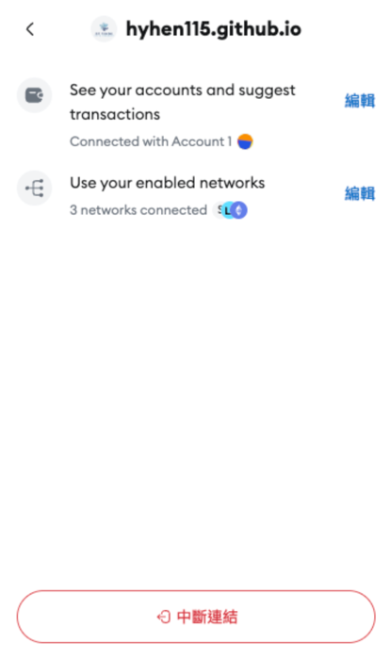

After Connect to the MetaMask Wallet, You Can Explore different Campaigns by Scrolling Down or Clicking the “Discover Campaigns” button on the Home Page.

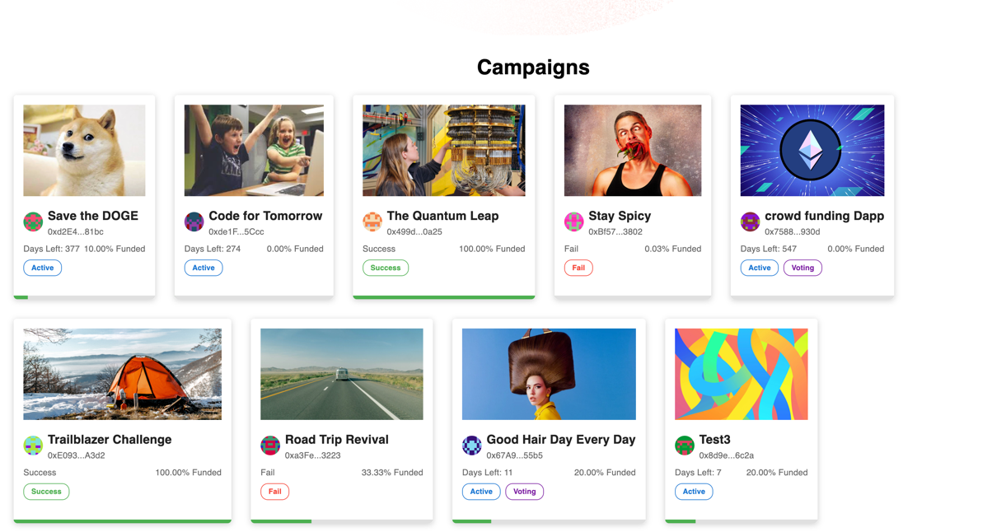

Each Campaign Card will show the remaining time, % of funds, status of the campaign [Active, Success, Fail] and Voting status of campaign [Voting].

Clicking these Campaign Cards can direct you to a detailed Page of the Campaign:

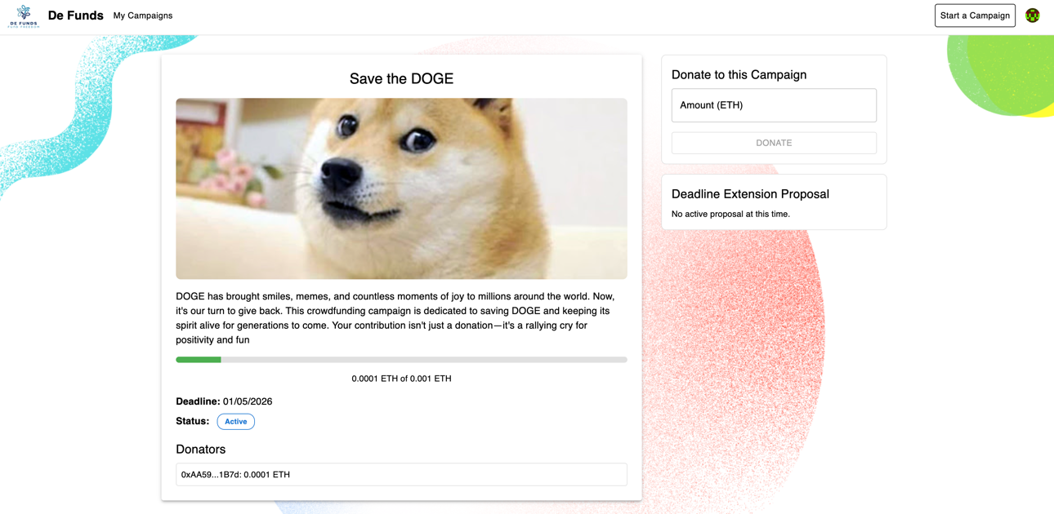

**Create and Manage Your Campaigns**

To Create a Campaign, You Must connect to the MetaMask Wallet in order to Press the “Start a Campaign” Button on the Navigation Bar:

It will Navigate to the Create Campaign Page:

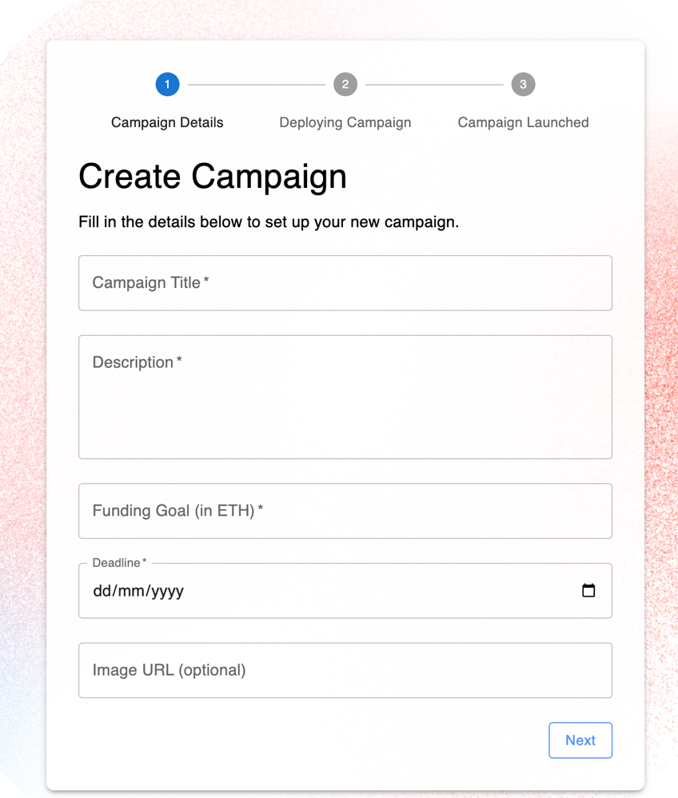

To Create a Campaign, you need to fill in all required, Deadline MUST be in the future, Funding Goal must larger than or equal to 0.0001 ETH.

After you filled all valid details. Click the Next Button, Pay the Gas Fee and wait for the Campaign to be Deployed.

After successful deploy:

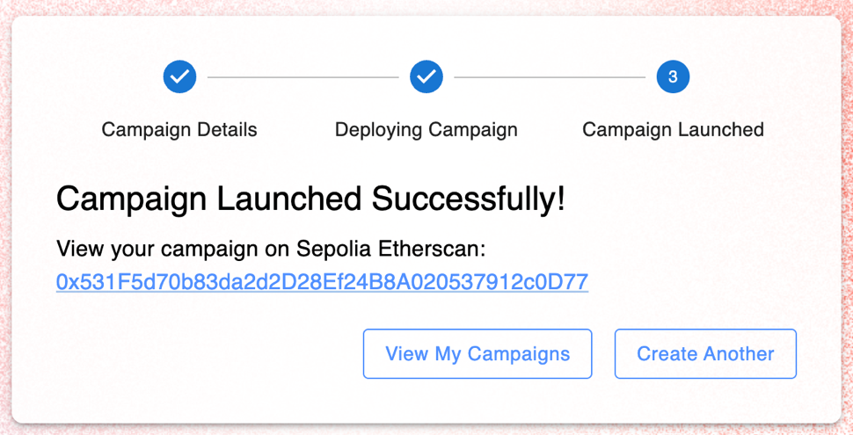

You can view your campaign on Sepolia Etherscan by clicking on the address of the campaign address or Create Another Cmapaign.

To Manage Your Campaigns, Click “My Campaign” Button on the Navigation Bar:

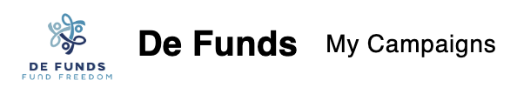

It will navigate to the MyCampaigns Pages:

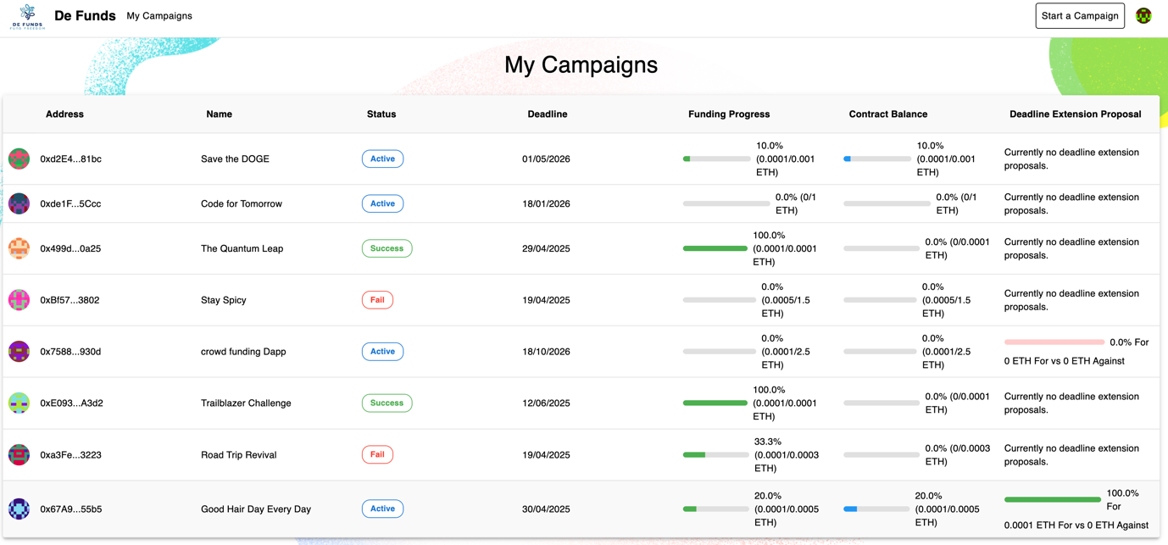

You can have a look for Your Campaign’s brief details: Name, Status, Deadline, Funding Progress, Campaign Contract Balance, Deadline Extension Proposal.

To further Manage Your Campaigns, just Click the Campaign you want to manage on the Campaign Table.

In the Campaign Details Page

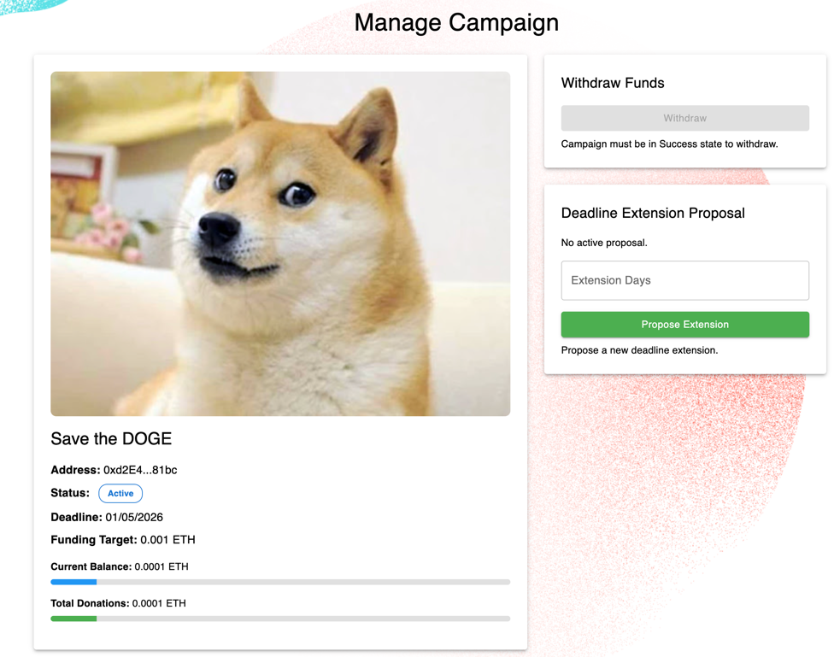

You are able to see the details of your campaign, and you can withdraw funds and propose any deadline extension proposal here.

**Propose Deadline Extensions**

To propose Deadline Extensions You need to access the MyCampaign page and click on the campaign you want to manage:

https://hyhen115.github.io/DeFunds/campaign/<CampaignAddress>/manage



Just enter the days of Deadline Extension you want and propose the proposal. (Gas fee is needed)

**Rules of the Extension Proposal:**

1. Only one Proposal can be active per Campaign
2. Extension Proposal will only be active for 3 Days
3. Only when the total Donations >= 50% of the target of the Campaign Owner can proposal an Extension Proposal
4. Only Donators are allowed to vote for/against for the Extension Proposal

* Each vote will have a weight of the value of Donations donated to the campaign for a reward for the supportiveness on the campaign.

E.g if a Donator donated 100ETH on the campaign the Donator’s vote will have 100 weights

* To if for votes > 50% of donations -> win and deadline will extend after the proposal has ended and needed the owner to confirm the results, otherwise deadline will not be extended
* Incentives for the voters: if donator trust the campaign owner, vote for to let the campaign gain more time and successfully finished the campaign, else if donator don’t trust the campaign owner, vote against and hope the campaign fails and they can request for a refund.

1. When Extension Proposal is active, Users cannot donate to the campaign

* This is to prevent new voters from skewing the decision-making process mid-vote, add integrity to the voting system.

1. After the Voting Period is ended, Campaign owner MUST confirm the voting result in the Campaign Details page for Owner to extend deadline of the campaign

**Donate & Vote for your supported Campaigns**

To Donate or Vote for your supported Campaigns, you can click the Campaign Cards on the Home Screen and navigate to the Campaign Details page.

https://hyhen115.github.io/DeFunds/campaign/<CampaignAddress>

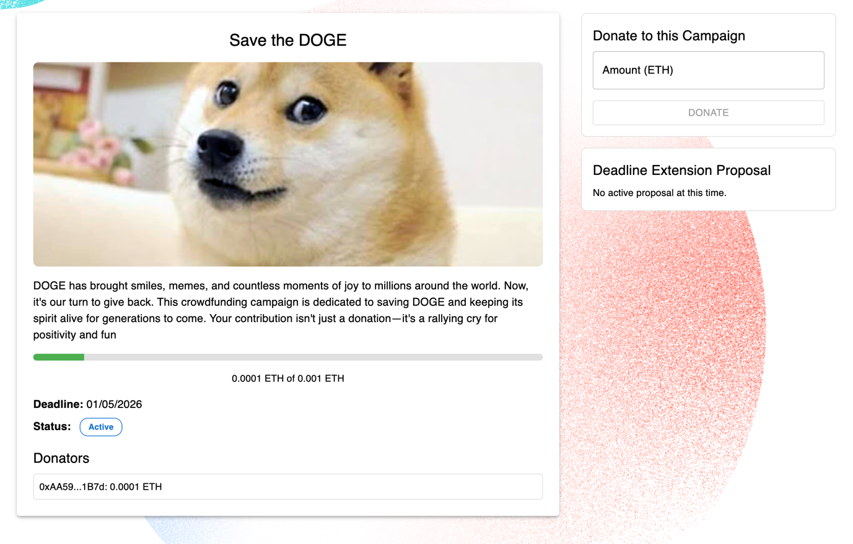

To Donate to the campaign, you just need to enter the amount of ETH you want to donate and press the “DONATE” button and pay the gas fee to donate to the campaign.

If a Deadline Extension Proposal is Active and you are one of the donators of the campaign and you have not voted before, the Deadline Extension Proposal will appear:

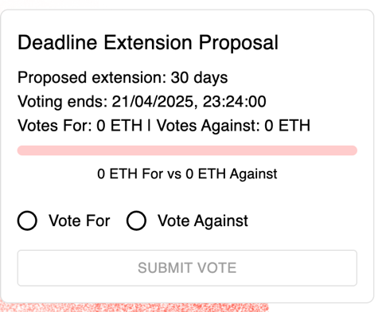

Just select what to vote, and press “SUBMIT VOTE” button to vote (gas fee needed)

**Get Funds for your Project**

If the Campaign is success. Press the “Withdraw” Button to withdraw All Balance form the Campaign contract.

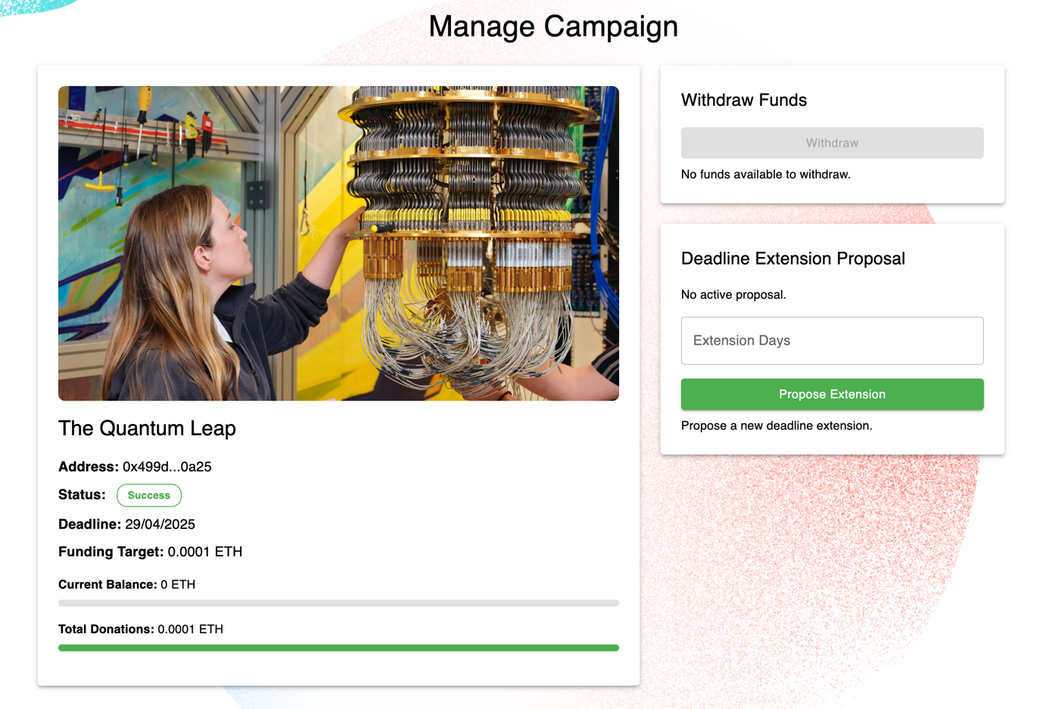

After withdrawing the funds out of the contract, the Current Balance of the Contract should be 0 ETH.

**Refund if Campaigns are Failed**

If You are a donator and the campaign is failed, you can click the “REQUEST REFUND” button to request a refund for your donations, your previous donations will be extracted from the campaign contract.

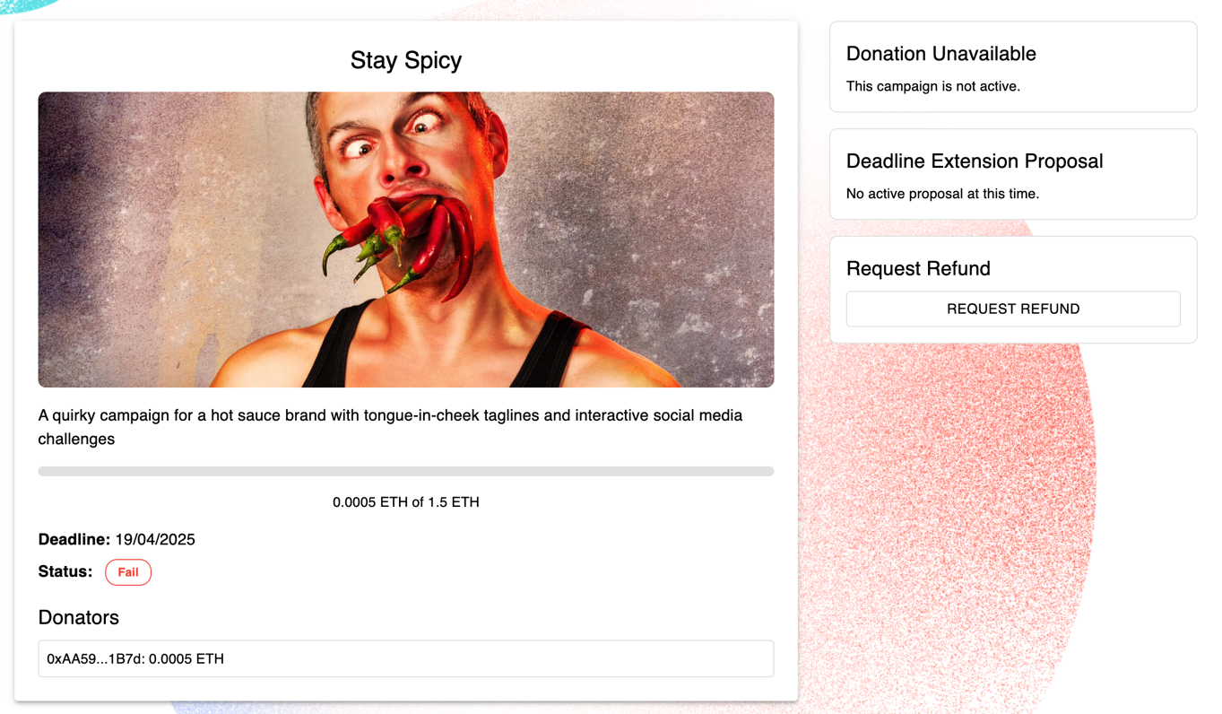

**Security Measures for Smart Contracts**

**crowdfundingFactory.sol**

**ReentrancyGuard –** **nonReentrant modifier**

Protects createCampaign() against potential reentrancy attacks

**OnlyOwner modifier**

Restrict access for togglePause() mainly for website maintainance and only factory owner can access it

**whenNotPaused modifier**

Allows pausing campaign creation in maintainance or other error happens

**createCampaign() Input validations**

name length: >0 can’t be empty

campaign target: >0

deadline: > block.timestamp to avoid potential integer underflow and unvalid deadlines

**crowdfunding.sol**

**ReentrancyGuard –** **nonReentrant modifier**

To protect withdraw() and refund() from Reentrancy Attacks as they call external functions .transfer()

**OnlyOwner modifier**

To restrict access to sensitive functions withdraw() and proposeDeadlineExtension(), confirmDeadlineExtension() which is exclusive to campaign owners

**campaignActive modifier**

To restrict access of any unvalid actions for functions donate(), propopseDeadlineExtension(), voteOnDeadlineExtension(), confirmDeadlineExtension(), to avoid cases like donate even campaign is success or failed

**Input Validations**

constructor:

same validations as createCampaign() on crowdfundingFactory.sol

donate():

msg.value > 0 to donate

require !curProposal.active, prevent new voters from skewing the decision-making process mid-vote, adds integrity to the voting system.

withdraw():

first update Campaign State using refreshCampaignState() then require campaign state is success to continue withdraw

checking balance is not 0 in the campaign to transfer ETH from contract to owner waller

payable(owner).transfer(balance); ensures only transfer to the owner not msg sender even onlyOwner modifier is activated, as miners can change the parameter of the functions

refund():

first update Campaign State using refreshCampaignState() then make user the campaign is failed to continue

make sure the campaign contract have balance to refund

proposeDeadlineExtension():

require only one proposal is activated, avoid double proposal

require extension period > 0

reuqier totalDonation >= 50% of targets

calculations: totalDonation * 2 > target.: avoid division by zero error or integer division truncation issues. And to reduce the impacts of Sybil Attacks, ensuring at least 50% of funds are fulfills so when a deadline extension vote is going on, sybil attackers need a higher cost for attacking and controlling the weighted vote.

voteOnDeadlineExtension():

ensure proposal is active

ensure the current time is valid for voter to vote

ensure only donator can vote

ensure no double voting

ensure the vote weight is > 0

confirmDeadlineExtension():

ensure a proposal is active

ensure the vote is already ended and ready for the owner to confirm the vote result

**Safe fund transfers**

In withdraw() and refund() uses transfer() with balance checks and update the states first then perform transfer() to eliminate the impact of any failure transfers()

**Weighted voting**

In safety perspective weighted voting is to eliminate the impact of Sybil Attacks as the cost of impact on the votes needs to have a great cost Attackers or Campaign Owners cannot easily use Sybil Attacks to dominate the voting power as it will be super expensive

**Single vote checking**

We have a mapping to track if the donator has voted hasVoted[msg.sender] to avoid double voting

**Avoid 0 division calculations on voting mechanism**

confirmDeadlineExtension() will check if the votes >50% to pass the proposal, voteFor > totalDonation/2 will cause some division by zero error or integer division truncation issues so we change it to voteFor * 2 > totalDonations

**Test Cases & logs**

Below I uses manual testing and ai gen testing, I uses ai gen testing first and manual tested most the remaining possible test cases. For Ai gen testing cases and results I have putted the files and codes under contract/test/ you are able to find in the source code or my github page <https://github.com/Hyhen115/DeFunds>

**Testcase and Test result generated by** [**https://mycontract.fun/**](https://mycontract.fun/)

Details please refer to contract/test/testcase.sol or contract/test/testResult.sol

Test Case 1: Donation Success and State Update

Test Case 2: Donation with Zero Value Should Revert

Test Case 3: Withdraw Finds Successfully After Reaching Target

Test Case 4: Refund Funds After Campaign Failure

Test Case 5: Propose Deadline Extension (Only Owner, Conditions Met)

Test Case 6: Vote ono Deadline Extension and Confirm Extension

Test Case 7: Voting Reverts When Donator Votes Twice

Test Case 8: Create Campaign via Factory (Successful Creation)

Test Case 9: Toggle Pause in Factory Prevents Campaign Ccreation

Suite result: ok. 9 passed; 0 failed; 0 skipped; finished in 2.43ms (1.80ms CPU time)

Ran 1 test suite in 1.28s (2.43ms CPU time): 9 tests passed, 0 failed, 0 skipped (9 total tests)

**Testcase and Test result by Manual Testing**

Test Case 1: Donation During Voting Period Should Revert

* Donate 10 wei when curProposal.active is true

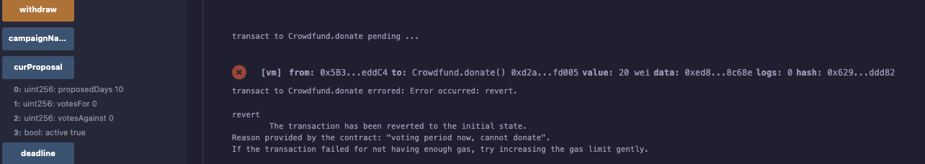

Test Case 2: Non-Donator Vote should revert

* 0xdD870fA1b7C4700F2BD7f44238821C26f7392148 is a non donator

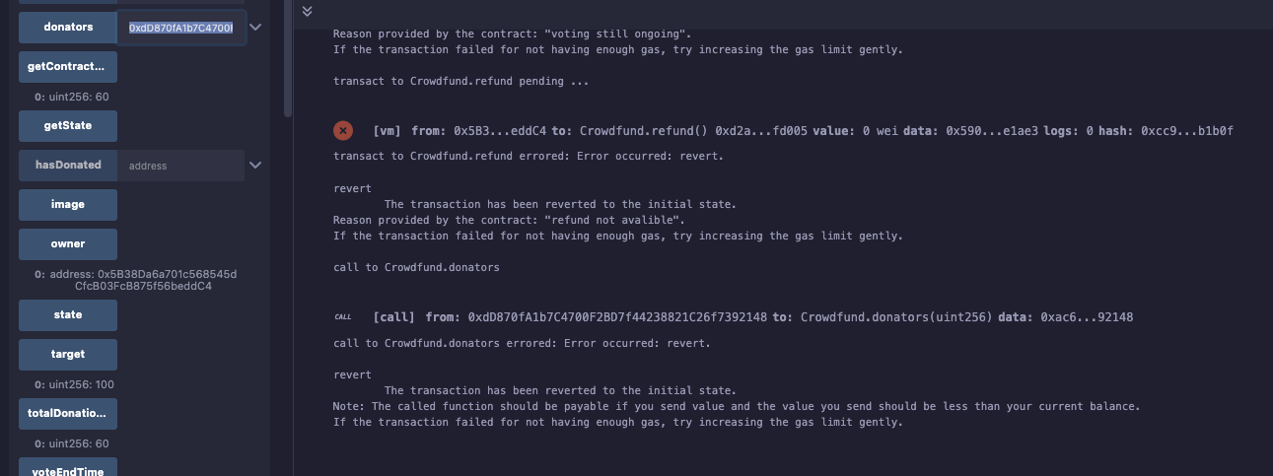

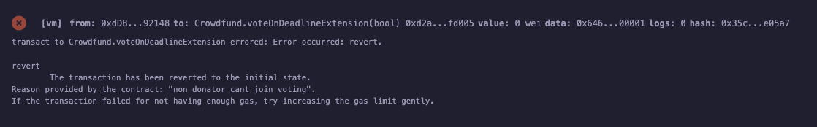

Test Case 3: Refund Attempt in Success State Should Revert

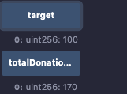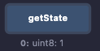

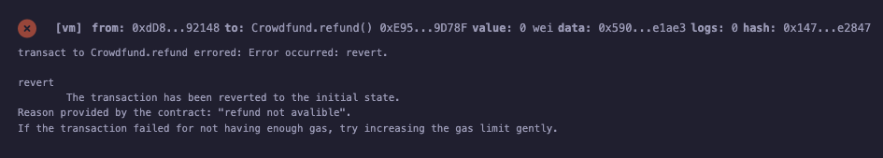

Test Case 4: Non-Owner Proposing Deadline Extension Should Revert

* Owner:

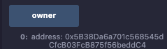

Sender: 0x1aE0EA34a72D944a8C7603FfB3eC30a6669E454C

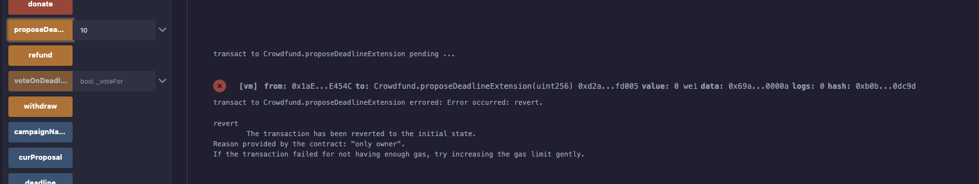

Test Case 5: Confirm Deadline Extension with Insufficient Votes

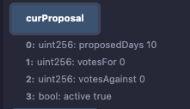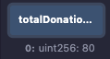

0 vs 0 , 80 total donations

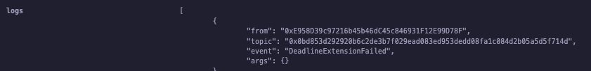

Test Case 6: Create Campaign with Invalid Parameters Should Revert

* Invalid target

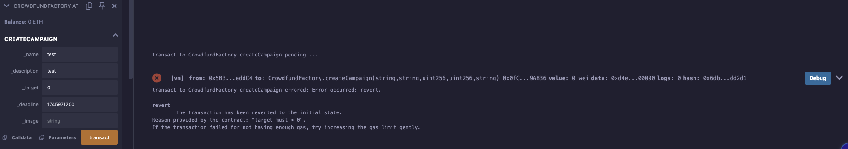

Test Case 7: Withdraw Attempt with Zero Balance Should Revert

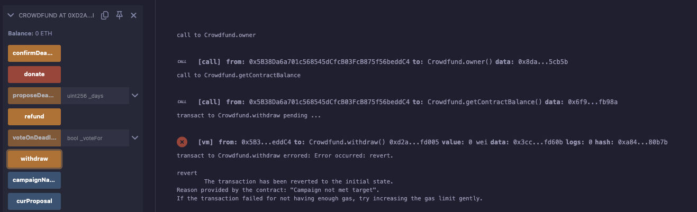

Test Case 8: Propose Deadline Extension with Insufficient Funding Should Revert

* 10 wei funds / 100 target

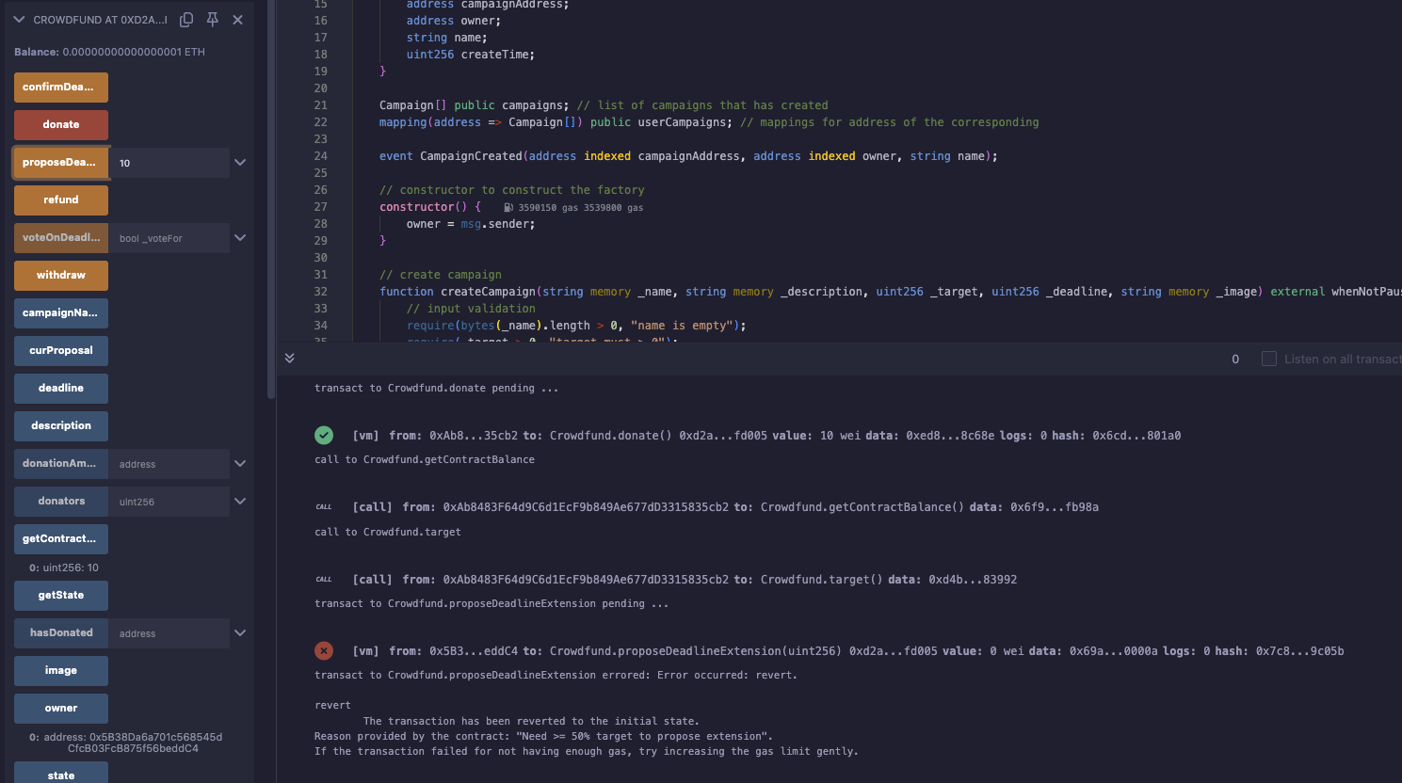

* Deadline 123

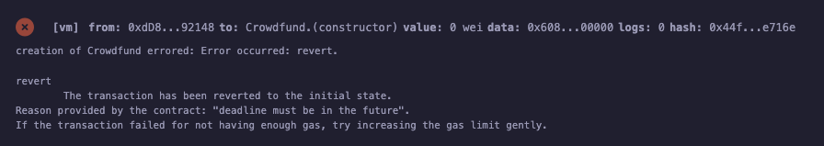

Test Case 9: Confirm Deadline Extension with No Votes



Total donation is 80

Emited DeadlineExtensionFailed

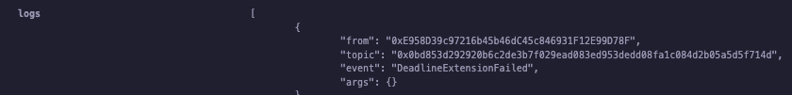

Test Case 10: Refund Attempt by Non-Donor Should Revert

* 0xdD870fA1b7C4700F2BD7f44238821C26f7392148 is a non donator



Cannot refund

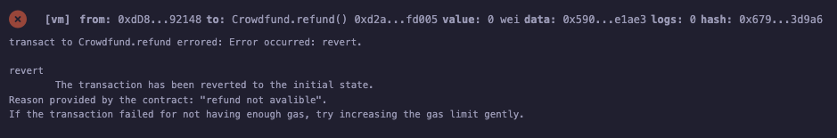

Test Case 11: Propose Deadline Extension with Zero Days Should Revert

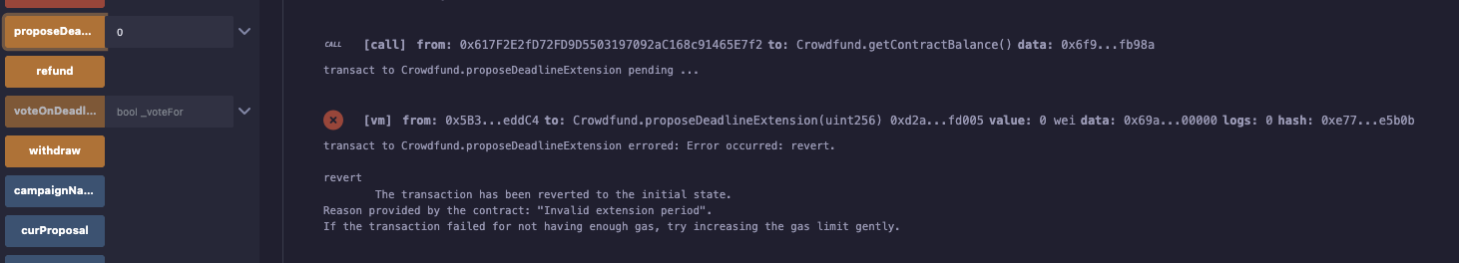

Test Case 12: Confirm Deadline Extension Before Voting Period Ends Should Revert

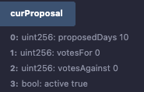

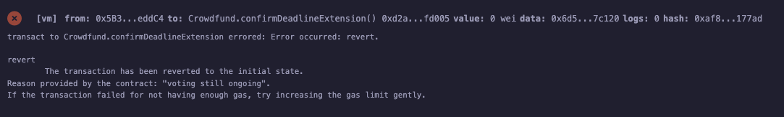

Test Case 13: Multiple Donors Voting with Exact 50% VotesFor Should Fail

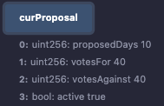

40 vs 40 with total 80

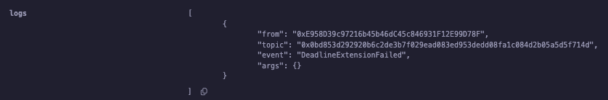

Emited deadlineExtension Failed